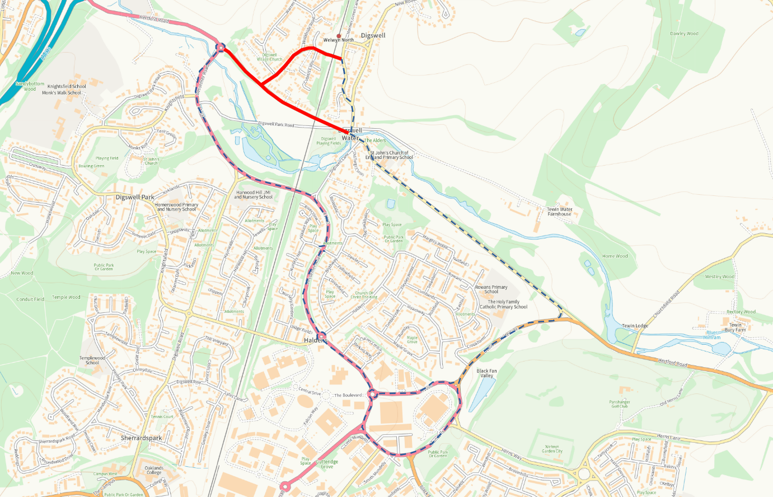

TEMPORARY TRAFFIC REGULATION ORDER

MEM250010-1 Station Rd

Ferryhills Close

North
Station Road

Harmer Green Lane

Hertford Road

A1000 Bessemer Road
A1000 Bessemer Road
A1000 Mundells
B1000 Waterside
Hertford Road
© Crown copyright and database rights 2024 OS EUL AC0000849954. You are permitted to use this data solely to enable you to respond to, or interact with, the organisation that provided you with the data. You are not permitted to copy, sub-license, distribute or sell any of this data to third parties in any form.

Road Closure &
Waiting Restrictions

Diversion

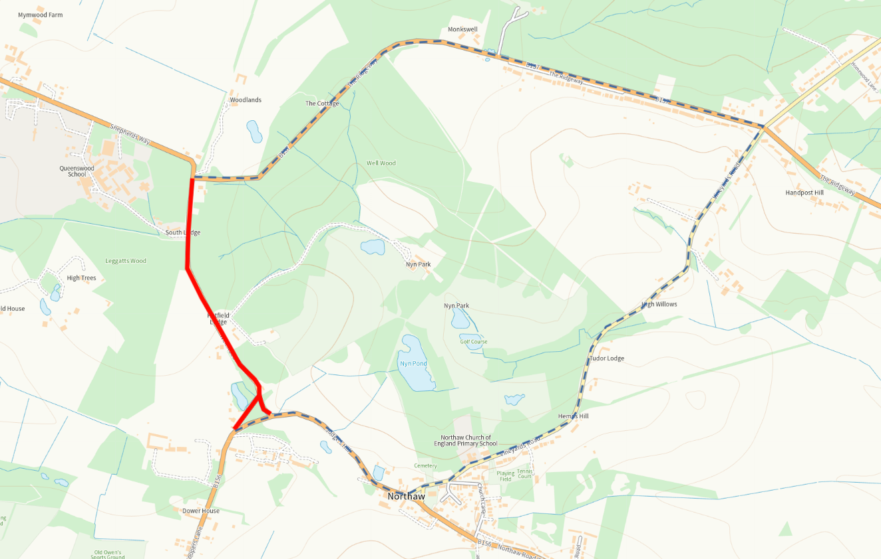

TEMPORARY TRAFFIC REGULATION ORDER

MEM250011-1 Well Rd

Ferryhills Close
B157 The Ridgeway

North

B156 Judges Hill
Well Road
Vineyards Road
© Crown copyright and database rights 2024 OS EUL AC0000849954. You are permitted to use this data solely to enable you to respond to, or interact with, the organisation that provided you with the data. You are not permitted to copy, sub-license, distribute or sell any of this data to third parties in any form.

Road Closure &
Waiting Restrictions

Diversion

